**##### DAILY MONITORING ACTIVITY #############**

PLEASE FOLLOW 5 S RULE IN DAILY MONITERING PURPOSE.

--------------------------------------------------------------------------------------------------------------------------------------------------------------------------------------------------------------------------------------------------

1. STATUS OF THE DATABASE

2. STATUS OF THE SERVICE

3. STATUS OF THE LISTNERS

4. STATUS OF THE STOREGE

5. STATUS OF THE SYNC TO STANDBYDB,BLOCKING SESSIONS,BACKUPS AND ALERT LOGS

--------------------------------------------------------------------------------------------------------------------------------------------------------------------------------------------------------------------------------------------------

1) Process monitoring:-

ps -ef | grep pmon

2) Database running status:(Database Name):-

srvctl status database -d AMSPRD



3) Services running status:(Database Name):-

srvctl status service -d AMSPRD



4) Listener running status check: lsnrctl status listener (By default name will be listener only):-

srvctl status listener



lsnrctl status

5) Node Apps Health Check status:-

srvctl status nodeapps

6) SCAN VIP Health Check status:-

srvctl status scan

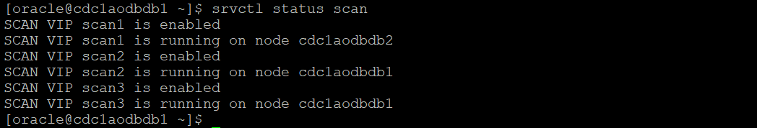

7) ASM Health Check status:-

srvctl status asm



8) Server Health Check status:-

srvctl status server -n cdc1aodbdb1 -a

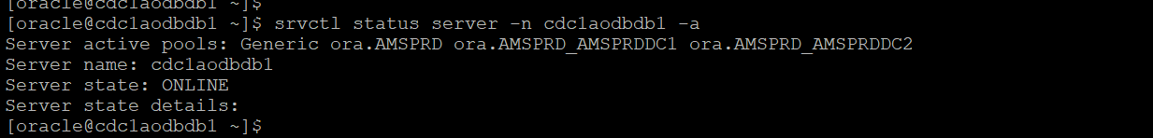

srvctl status server -n cdc1aodbdb2 -a

9) Mount points check:(mount points should be under 75%):-

df -h

du -sh *

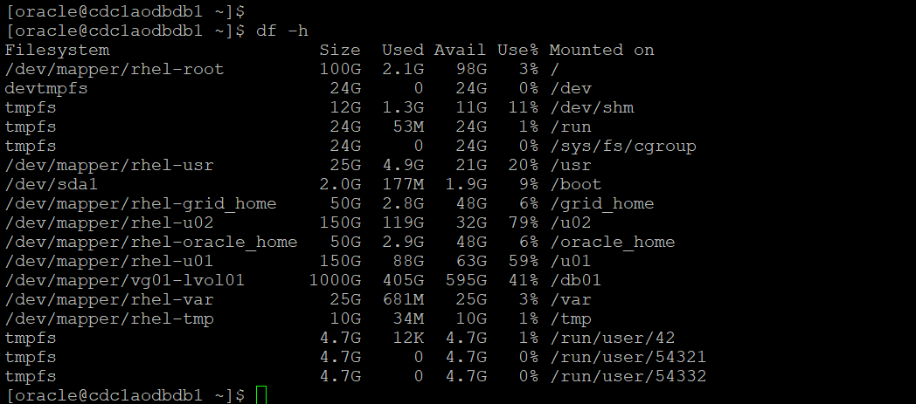

10) Checking DATABASE and CLUSTER alert logs Location:-

TO KNOW ALERT LOG LOCATIONS:--

IN OS LEVEL:-

adrci

adrci> show home;

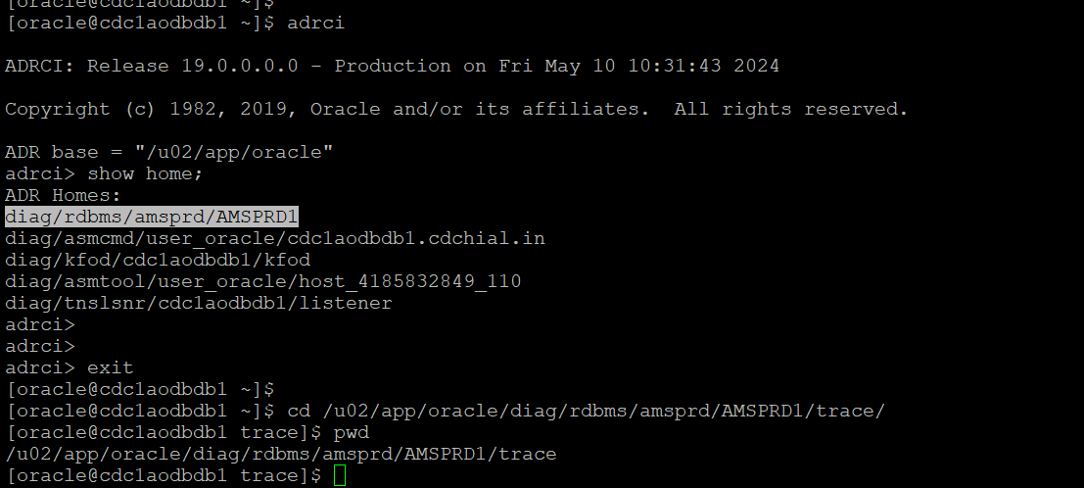

PRIMARY:-

cd /u02/app/oracle/diag/rdbms/amsprd/AMSPRD1/trace

cd /u02/app/oracle/diag/rdbms/imbdb/IMBDB1/trace

cd /u02/app/oracle/diag/rdbms/libertydb/LIBERTYD1/trace

cd /u02/app/oracle/diag/rdbms/bawdb/BAWDB1/trace

cd /u01/app/oracle/diag/crs/cdc1aodbdb1/crs/trace

cd /u01/app/oracle/diag/crs/prdbawdb1/crs/trace

STANDBY:-

cd /u02/app/oracle/diag/rdbms/amsprdstby/AMSPRDSTBY1/trace/

cd /u02/app/oracle/diag/rdbms/imbdbstby/IMBDBSTBY1/trace

cd /u02/app/oracle/diag/rdbms/libertydbstby/LIBERTYDSTBY1/trace

cd /u02/app/oracle/diag/rdbms/bawdb/BAWDB1/trace

cd /u01/app/oracle/diag/crs/cdc2aodbdb1/crs/trace

cd /u01/app/oracle/diag/crs/cdc2prdbawdb1/crs/trace

ls -lart al*.log

tail -500f al*.log

tail -1500f al*.log

head -1000 al*.log

head -1500 al*.log

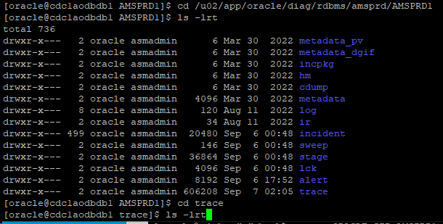

SQL>

select value from v$diag_info;

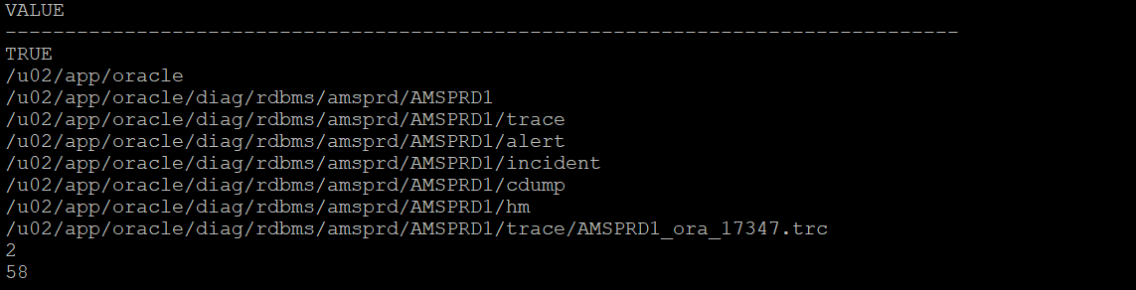

--------------------------------------------------------------------------------------------------------------------------------------------------------------------------------------------------------------------------------------------------

switch to grid:-

su - grid

<grid_password>

11) Cluster Health Check status:-

crsctl check cluster -all

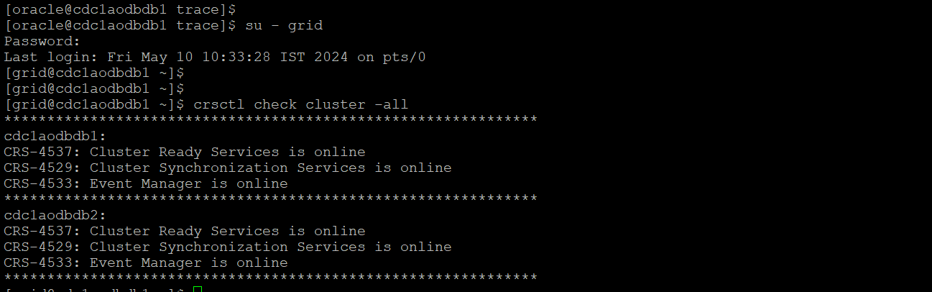

crsctl check crs

12) Cluster RESOURCE Health Check status:-

crsctl status resource -t

13) Cluster OCR file backup Check status:-

ocrconfig -showbackup

14) ASMCMD check: (check archivelogs space and maintain 2 days archivelogs):-

asmcmd

lsdg

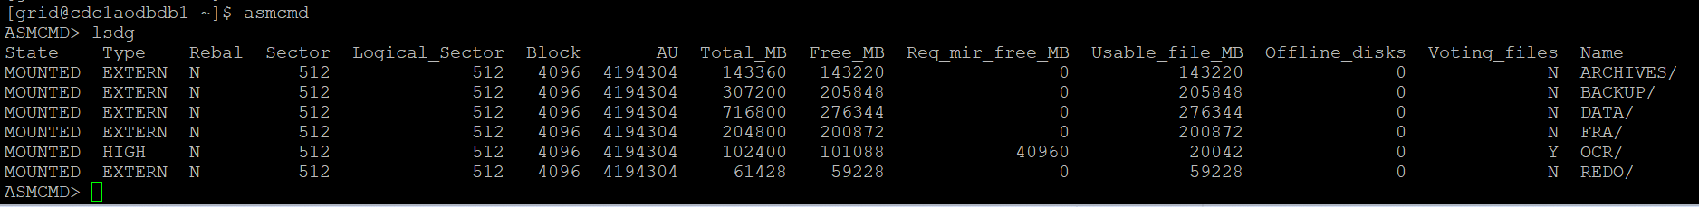

15) Crosscheck archivelogs: After clearing archives we need to crosscheck the archive logs, if not the backup of database will not happen on the next day.

rm –rf directory name – remove the old archives if space is less:-

rman target /

Crosscheck archivelog all;

delete noprompt expired archivelog all;

-----------------------------------------------------------------------------------------------------------------------

16) Connect to the database and check name of the database:-

export ORACLE_SID=AMSPRD1

sqlplus / as sysdba

select status,name,DATABASE_ROLE from v$instance,v$database;

set lines 200 pages 200;

select name,INSTANCE_NUMBER,INSTANCE_NAME,STATUS,OPEN_MODE,switchover_status from gv$instance a,gv$database b where a.inst_id=b.inst_id;

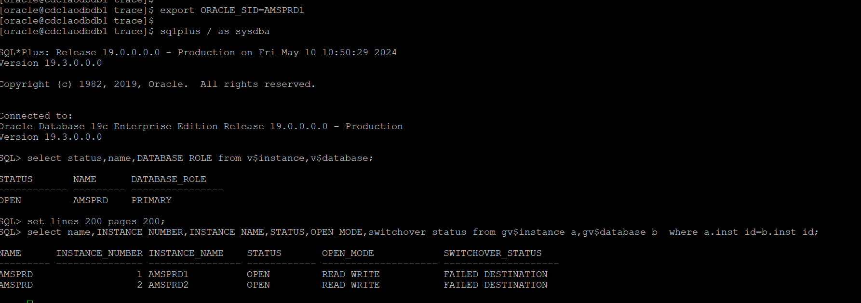

17) Backup status check:-

col STATUS format a9

col hrs format 999.99

col start_time format A20

col end_time format A20

SET LINES 999 PAGES 999;

select SESSION_KEY, INPUT_TYPE, STATUS, to_char(START_TIME,'mm/dd/yy hh24:mi') start_time,

to_char(END_TIME,'mm/dd/yyhh24:mi') end_time, elapsed_seconds/3600 hrs

from V$RMAN_BACKUP_JOB_DETAILS where start_time > sysdate-6 order by session_key;

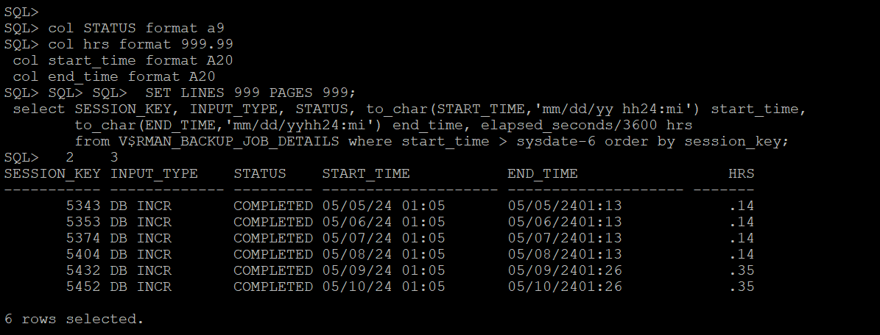

* Incase backup fails take manually:-

rman target /

rman> backup incremental level 1 database;

or

crontab -l

sh /tmp/scripts/backup.sh LIBERTYD1 inc > /tmp/inc_backup.log

--------------------------------------------------------------------------------------------------------------------------------------------------------------------------------------------------------------------------------------------------

18) Blocking sessions status check:-

select

blocking_session,

sid,

serial#,INST_ID,

wait_class,

seconds_in_wait,sql_id

from

gv$session

where

blocking_session is not NULL

order by

blocking_session;

* Incase of any blocking sessions kil with information after application team:-------------

alter system kill session '<sid number>,<serial#>';

alter system kill session '<sid number>,<serial#>,@instance';

* Incase of any locking sessions:----------

col owner for a30;

col name for a30;

select * from dba_dml_locks;

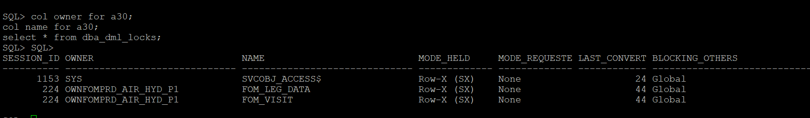

* For find out serial# value:---------------------------

select serial# from v$session where SID=38;

* Detect lock objects:----------------------

set lines 200 pages 200

col owner for a30

col object_name for a30

col object_type for a20

col sid for 9999

col status for a20

select

c.owner,

c.object_name,

c.object_type,

b.sid,

b.serial#,

b.status,

b.osuser,

b.machine

from v$locked_object a ,

v$session b,

dba_objects c

where

b.sid = a.session_id

and

a.object_id = c.object_id;

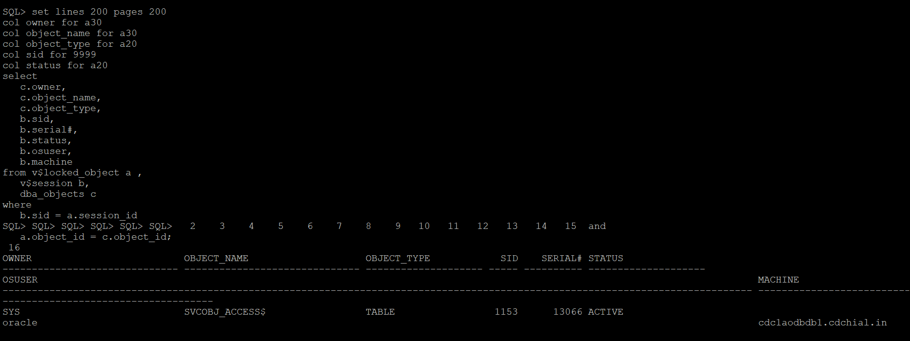

-------------------------------------------------------------------------------------------------------------------------

19) Inactive sessions check:-

select status,count(*) from gv$session group by status;

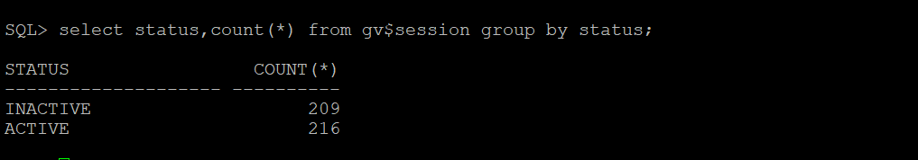

* TO CONNECTED USERS ON THAT TIME:-------------------------------

set lines 200;

set pages 200;

col username for a25;

col machine for a25;

col osuser for a30;

select sid,serial#,username,machine,program,osuser from gv$session where username not in ('SYS','SYSTEM','SYSMAN','DBSNMP','NULL','SYSRAC') order by username,MACHINE,PROGRAM,OSUSER;

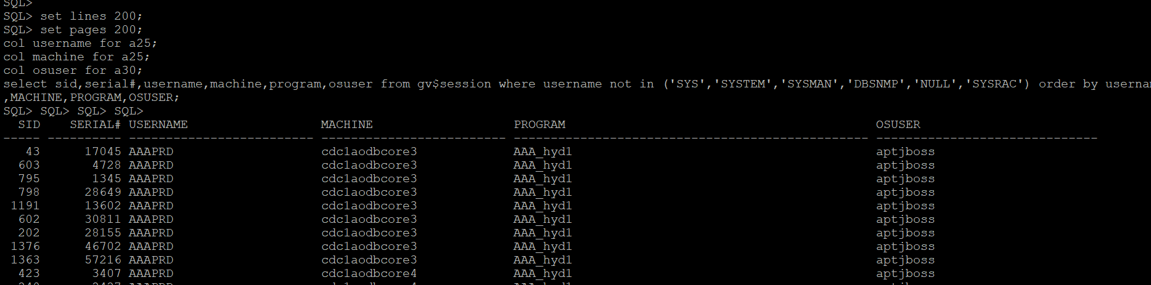

* TO CHECK LOAD BALANCING IN ON THAT TIME:-------------------------------------

select inst_id,username,count(*) from gv$session where username is not null group by inst_id,username order by 2,1;

* TO CHECK THE LONG RUNNING SESSIONS:-------------------------------------

set lines 200 pages 200;

col sid for 99999999;

col TOTALWORK for a40;

col sofar for a40;

* select SID,TARGET||OPNAME TARGET, TOTALWORK, SOFAR,TIME_REMAINING/60 Mins_Remaining,ELAPSED_SECONDS,SQL_ID from gv$session_longops where TIME_REMAINING>0 order by TIME_REMAINING;

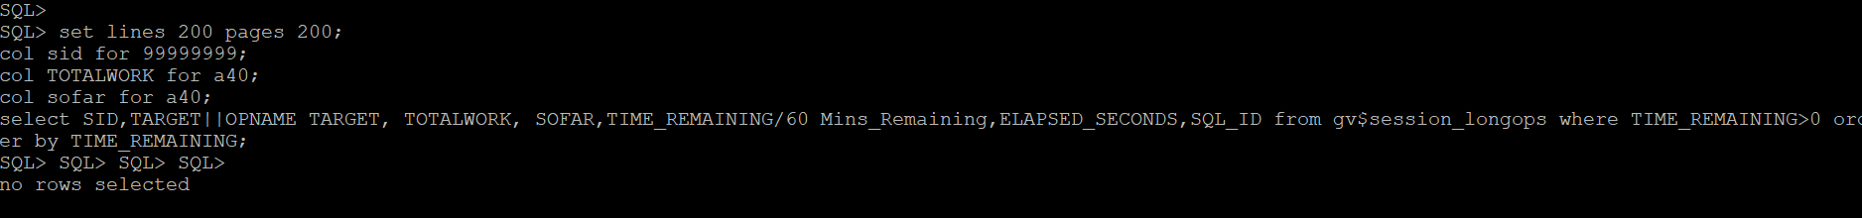

20) Check the usage of SGA :-

select round(used.bytes /1024/1024/1024 ,2) used_gb

, round(free.bytes /1024/1024/1024 ,2) free_gb

, round(tot.bytes /1024/1024/1024 ,2) total_gb

from (select sum(bytes) bytes

from v$sgastat

where name != 'free memory') used

, (select sum(bytes) bytes

from v$sgastat

where name = 'free memory') free

, (select sum(bytes) bytes

from v$sgastat) tot ;

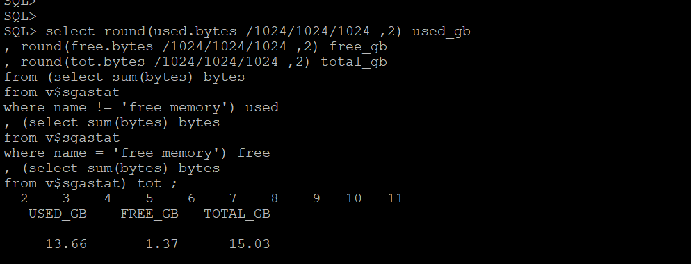

21) TO CHECK THE TABLESPACE USAGE:-

set pages 200;

select round(sum(bytes)/1024/1024/1024,2) Gbytes_used,round(sum(MAXBYTES)/1024/1024/1024,2) Gbytes_alloc

,tablespace_name--,round((sum(bytes)/sum(maxbytes))*100,2) pct

from dba_data_files where tablespace_name not like '%UNDO%' group by tablespace_name order by 1 desc;

set linesize 3000

column dummy noprint

column pct_used format 999.9 heading "%|Used"

column name format a19 heading "Tablespace Name"

column Kbytes format 999,999,999 heading "MBytes"

column used format 999,999,999 heading "Used"

column free format 999,999,999 heading "Free"

column largest format 999,999,999 heading "Largest"

column max_size format 999,999,999 heading "MaxPoss|Mbytes"

column pct_max_used format 999.9 heading "%|Max|Used"

break on report

compute sum of kbytes on report

compute sum of free on report

compute sum of used on report

select (select decode(extent_management,'LOCAL','*',' ')

from dba_tablespaces where tablespace_name = b.tablespace_name) ||

nvl(b.tablespace_name,

nvl(a.tablespace_name,'UNKOWN')) name,

kbytes_alloc kbytes,

kbytes_alloc-nvl(kbytes_free,0) used,

nvl(kbytes_free,0) free,

((kbytes_alloc-nvl(kbytes_free,0))/

kbytes_alloc)*100 pct_used,

nvl(largest,0) largest,

nvl(kbytes_max,kbytes_alloc) Max_Size,

decode( kbytes_max, 0, 0, (kbytes_alloc/kbytes_max)*100) pct_max_used

from ( select sum(bytes)/1024/1024 Kbytes_free,

max(bytes)/1024/1024 largest,

tablespace_name

from sys.dba_free_space

group by tablespace_name ) a,

( select sum(bytes)/1024/1024 Kbytes_alloc,

sum(maxbytes)/1024/1024 Kbytes_max,

tablespace_name

from sys.dba_data_files

group by tablespace_name

union all

select sum(bytes)/1024/1024 Kbytes_alloc,

sum(maxbytes)/1024/1024 Kbytes_max,

tablespace_name

from sys.dba_temp_files

group by tablespace_name )b

where a.tablespace_name (+) = b.tablespace_name

order by 5;

--------------------------------------------------------------------------------------------------------------------------------------------------------------------------------------------------------------------------------------------------

* SET LINESIZE 200;

SELECT tablespace_name,

block_size,

extent_management,

segment_space_management,

status

FROM dba_tablespaces

ORDER BY tablespace_name;

col FILE_NAME for a55;

set lines 200 pages 200;

SELECT file_id,file_name, ROUND(bytes/1024/1024) AS size_mb,ROUND(maxbytes/1024/1024) AS max_size_mb,autoextensible,increment_by,status FROM dba_data_files WHERE tablespace_name = 'SYSTEM';

22) Disk group free space status check:-

SET ECHO OFF

SET FEEDBACK 6

SET HEADING ON

SET LINESIZE 180

SET PAGESIZE 50000

SET TERMOUT ON

SET TIMING OFF

SET TRIMOUT ON

SET TRIMSPOOL ON

SET VERIFY OFF

CLEAR COLUMNS

CLEAR BREAKS

CLEAR COMPUTES

COLUMN group_name FORMAT a25 HEAD 'Disk Group|Name'

COLUMN state FORMAT a11 HEAD 'State'

COLUMN total_mb FORMAT 999,999,999 HEAD 'Total Size (GB)'

COLUMN free_mb FORMAT 999,999,999 HEAD 'Free Size (GB)'

COLUMN pct_free FORMAT 999.99 HEAD '% Free'

BREAK ON report ON disk_group_name SKIP 1

COMPUTE sum LABEL "Grand Total: " OF total_mb used_mb ON report

SELECT

name group_name

, state state

, total_mb/1024 total_mb

, free_mb/1024 free_mb

, ROUND(((free_mb / total_mb))*100, 2) pct_free

FROM

v$asm_diskgroup

WHERE

total_mb != 0

ORDER BY

Name

/

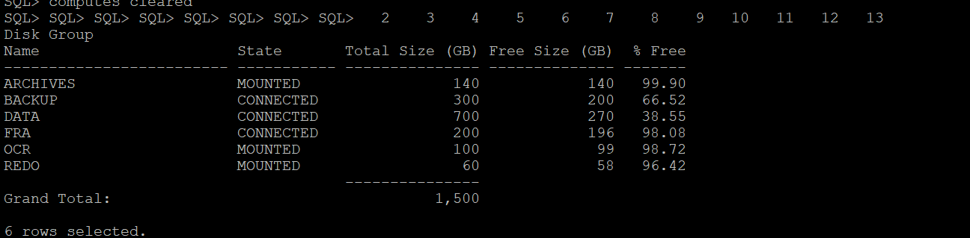

--------------------------------------------------------------------------------------------------------------------------------------------------------------------------------------------------------------------------------------------------

23) Check gap between DC1 and DC2 on primary:--------------------------------

set scan on

set feed off

set linesize 200

BREAK ON ROW SKIP 1s

column thread format a6;

column "PR - Archived" format a13;

column "STBY - Archived" format a15;

column "STBY - Applied" format a14;

column "Shipping GAP (PR -> STBY)" format a25;

column "Applied GAP (STBY -> STBY)" format a26;

--ACCEPT DEST PROMPT 'Enter the Standby Archive Log Destination : '

SELECT *

FROM (SELECT LPAD (t1, 4, ' ') "Thread",

LPAD (pricre, 9, ' ') "PR - Archived",

LPAD (stdcre, 10, ' ') "STBY - Archived",

LPAD (stdnapp, 9, ' ') "STBY - Applied",

LPAD (pricre - stdcre, 13, ' ')

"Shipping GAP (PR -> STBY)",

LPAD (stdcre - stdnapp, 15, ' ')

"Applied GAP (STBY -> STBY)"

FROM ( SELECT MAX (sequence#) stdcre, thread# t1

FROM v$archived_log

WHERE standby_dest = 'YES'

AND resetlogs_id IN

(SELECT MAX (RESETLOGS_ID)

FROM v$archived_log)

AND thread# IN (1, 2, 3, 4)

GROUP BY thread#) a,

( SELECT MAX (sequence#) stdnapp, thread# t2

FROM v$archived_log

WHERE standby_dest = 'YES'

AND resetlogs_id IN

(SELECT MAX (RESETLOGS_ID)

FROM v$archived_log)

AND thread# IN (1, 2, 3, 4)

AND applied = 'YES'

GROUP BY thread#) b,

( SELECT MAX (sequence#) pricre, thread# t3

FROM v$archived_log

WHERE standby_dest = 'NO'

AND resetlogs_id IN

(SELECT MAX (RESETLOGS_ID)

FROM v$archived_log)

AND thread# IN (1, 2, 3, 4)

GROUP BY thread#) c

WHERE a.t1 = b.t2 AND b.t2 = c.t3 AND c.t3 = a.t1)

ORDER BY 1

/

set feed on

break on off



-------------------------------------------------------------------------------------------------------------------------

24) To Verify indexes are valid are not:-

select owner,index_name ,tablespace_name ,null partition from dba_indexes where

status = 'UNUSABLE'

union all

select index_owner,index_name ,tablespace_name ,partition_name from dba_ind_partitions where

status = 'UNUSABLE';

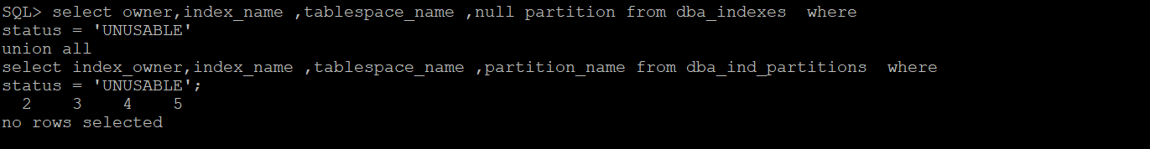

25) Dump location:---------------------

show parameter dump;

* SELECT SUM(PINS-RELOADS)/SUM(PINS)*100 as "Library Cache Hit Ratio" FROM v$librarycache;

* select sum(gets) as "Gets", sum(getmisses) as "Misses", (1-(sum(getmisses)/sum(gets)))*100 as "CACHE HIT RATIO" from gv$rowcache;

* SELECT round((P1.value + P2.value - P3.value) /

(P1.value + P2.value)*100,2) "Cache Hit Ratio (DB)"

FROM v$sysstat P1, v$sysstat P2, v$sysstat P3

WHERE P1.name = 'db block gets'

AND P2.name = 'consistent gets'

AND P3.name = 'physical reads';

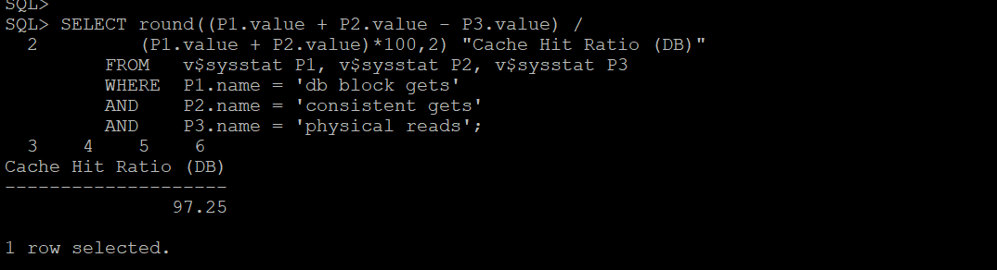

* col name for a30;

SELECT name, (1-(misses/gets))*100 AS "Ratio", sleeps FROM v$latch WHERE name in ('library cache', 'shared pool');

--------------------------------------------------------------------------------------------------------------------------------------------------------------------------------------------------------------------------------------------------

26) TO KNOW PING FILE STATUS:-

sudo ping 10.102.117.13 >> /tmp/dc1.txt



TO SEE FILE:-

less /tmp/dc1.txt

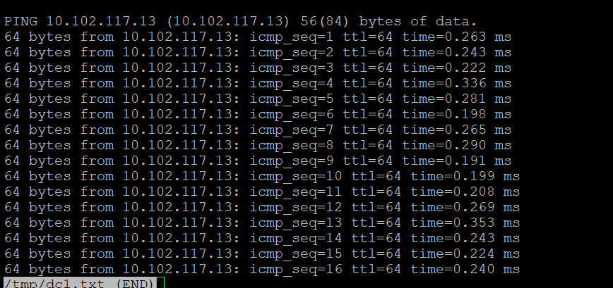

--------------------------------------------------------------------------------------------------------------------------------------------------------------------------------------------------------------------------------------------------

27) TO REMOVE/PURGE OLD TRACE IN ORACLE HOME FILES:- FOR MONTHLY ONCE

find . -type f -name "*.trc" -mtime +180 -exec rm -rf {} \;

find . -type f -name "*.trm" -mtime +180 -exec rm -rf {} \;

find . -type f -name 2023-05-10 -ls



--------------------------------------------------------------------------------------------------------------------------------------------------------------------------------------------------------------------------------------------------

28) On daily basis, (PURGEING FILES) we need to run the following commands for the effective performance of DB.

For DML statements, we have to give commit command. By performing this activity, we have check the blocking sessions by taking another session.

---------------------------------------------------------------------------------------------------------------------

# **IMBDB (10.102.123.11):**

On daily basis, we need to run the following commands for the effective performance of DB. For DML statements, we have to give commit command. By performing this activity, we have check the blocking sessions by taking another session.

1. delete from IMBDB.IMB_SRC_MSG_ORDER WHERE mq_msg_id<=(SELECT min(mq_msg_id) FROM IMBDB.IMB_SRC_MSG_ORDER S where received_at BETWEEN SYSDATE - (4 / 24) AND SYSDATE);

commit;

1. delete from IMBDB.IMB_TGT_MSG_ORDER WHERE mq_msg_id<=(SELECT min(mq_msg_id) FROM IMBDB.IMB_SRC_MSG_ORDER S where received_at BETWEEN SYSDATE - (4 / 24) AND SYSDATE);

commit;

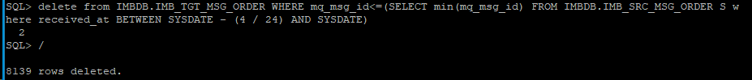

1. delete from IMBDB.IMB_ACK where GEN_TIME < (SYSDATE - 4/24);

commit;

# **LIBERTYDB:**

1. delete from libertydb.task_runs where startdate < (sysdate-1);

commit;

1. delete from LIBERTYDB.MSG_STREAM where LIB_CR_TIME < (SYSDATE - 3);

28) Archive log list:--

archive log list;

* TO SWITCH ARCHIVELOG:---------

ALTER SYSTEM ARCHIVE LOG CURRENT ;

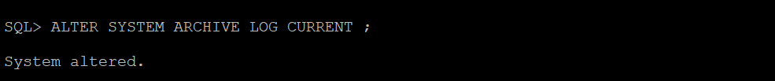

# **1.GATHER STATS:---**

## AMSPRD:

exec dbms_stats.gather_schema_stats( options=>'gather stale',estimate_percent=>10,degree=>8,no_invalidate=>true,cascade=>true,ownname=>'"OWNAFVPRD_AIR_HYD_P1"', method_opt=>' for all columns size 1 ');

exec dbms_stats.gather_schema_stats( options=>'gather stale',estimate_percent=>10,degree=>8,no_invalidate=>true,cascade=>true,ownname=>'"OWNAMGPRD"', method_opt=>' for all columns size 1 ');

exec dbms_stats.gather_schema_stats( options=>'gather stale',estimate_percent=>10,degree=>8,no_invalidate=>true,cascade=>true,ownname=>'"OWNAMGPRD_AIR_HYD_P1"', method_opt=>' for all columns size 1 ');

exec dbms_stats.gather_schema_stats( options=>'gather stale',estimate_percent=>10,degree=>8,no_invalidate=>true,cascade=>true,ownname=>'"OWNCORPRD"', method_opt=>' for all columns size 1 ');

exec dbms_stats.gather_schema_stats( options=>'gather stale',estimate_percent=>10,degree=>8,no_invalidate=>true,cascade=>true,ownname=>'"OWNFDSPRD"', method_opt=>' for all columns size 1 ');

exec dbms_stats.gather_schema_stats( options=>'gather stale',estimate_percent=>10,degree=>8,no_invalidate=>true,cascade=>true,ownname=>'"OWNAMGPRD"', method_opt=>' for all columns size 1 ');

exec dbms_stats.gather_schema_stats( options=>'gather stale',estimate_percent=>10,degree=>8,no_invalidate=>true,cascade=>true,ownname=>'"OWNFDSPRD_AIR_HYD_P1"', method_opt=>' for all columns size 1 ');

exec dbms_stats.gather_schema_stats( options=>'gather stale',estimate_percent=>10,degree=>8,no_invalidate=>true,cascade=>true,ownname=>'"OWNFIDPRD"', method_opt=>' for all columns size 1 ');

exec dbms_stats.gather_schema_stats( options=>'gather stale',estimate_percent=>10,degree=>8,no_invalidate=>true,cascade=>true,ownname=>'"OWNFOMPRD"', method_opt=>' for all columns size 1 ');

exec dbms_stats.gather_schema_stats( options=>'gather stale',estimate_percent=>10,degree=>8,no_invalidate=>true,cascade=>true,ownname=>'"OWNFOMPRD_AIR_HYD_P1"', method_opt=>' for all columns size 1 ');

exec dbms_stats.gather_schema_stats( options=>'gather stale',estimate_percent=>10,degree=>8,no_invalidate=>true,cascade=>true,ownname=>'"OWNMSCPRD"', method_opt=>' for all columns size 1 ');

exec dbms_stats.gather_schema_stats( options=>'gather stale',estimate_percent=>10,degree=>8,no_invalidate=>true,cascade=>true,ownname=>'"OWNMSCPRD_AIR_HYD_P1"', method_opt=>' for all columns size 1 ');

exec dbms_stats.gather_schema_stats( options=>'gather stale',estimate_percent=>10,degree=>8,no_invalidate=>true,cascade=>true,ownname=>'"OWNSDSPRD"', method_opt=>' for all columns size 1 ');

exec dbms_stats.gather_schema_stats( options=>'gather stale',estimate_percent=>10,degree=>8,no_invalidate=>true,cascade=>true,ownname=>'"OWNSDSPRD_AIR_HYD_P1"', method_opt=>' for all columns size 1 ');

exec dbms_stats.gather_schema_stats( options=>'gather stale',estimate_percent=>10,degree=>8,no_invalidate=>true,cascade=>true,ownname=>'"OWNSGAPRD"', method_opt=>' for all columns size 1 ');

exec dbms_stats.gather_schema_stats( options=>'gather stale',estimate_percent=>10,degree=>8,no_invalidate=>true,cascade=>true,ownname=>'"OWNSGAPRD_AIR_HYD_P1"', method_opt=>' for all columns size 1 ');

exec dbms_stats.gather_schema_stats( options=>'gather stale',estimate_percent=>10,degree=>8,no_invalidate=>true,cascade=>true,ownname=>'"OWNVIPPRD"', method_opt=>' for all columns size 1 ');

exec dbms_stats.gather_schema_stats( options=>'gather stale',estimate_percent=>10,degree=>8,no_invalidate=>true,cascade=>true,ownname=>'"OWNVIPPRD_AIR_HYD_P1"', method_opt=>' for all columns size 1 ');

exec dbms_stats.gather_schema_stats( options=>'gather stale',estimate_percent=>10,degree=>8,no_invalidate=>true,cascade=>true,ownname=>'"SDSPRD"', method_opt=>' for all columns size 1 ');

exec dbms_stats.gather_schema_stats( options=>'gather stale',estimate_percent=>10,degree=>8,no_invalidate=>true,cascade=>true,ownname=>'"SGAPRD"', method_opt=>' for all columns size 1 ');

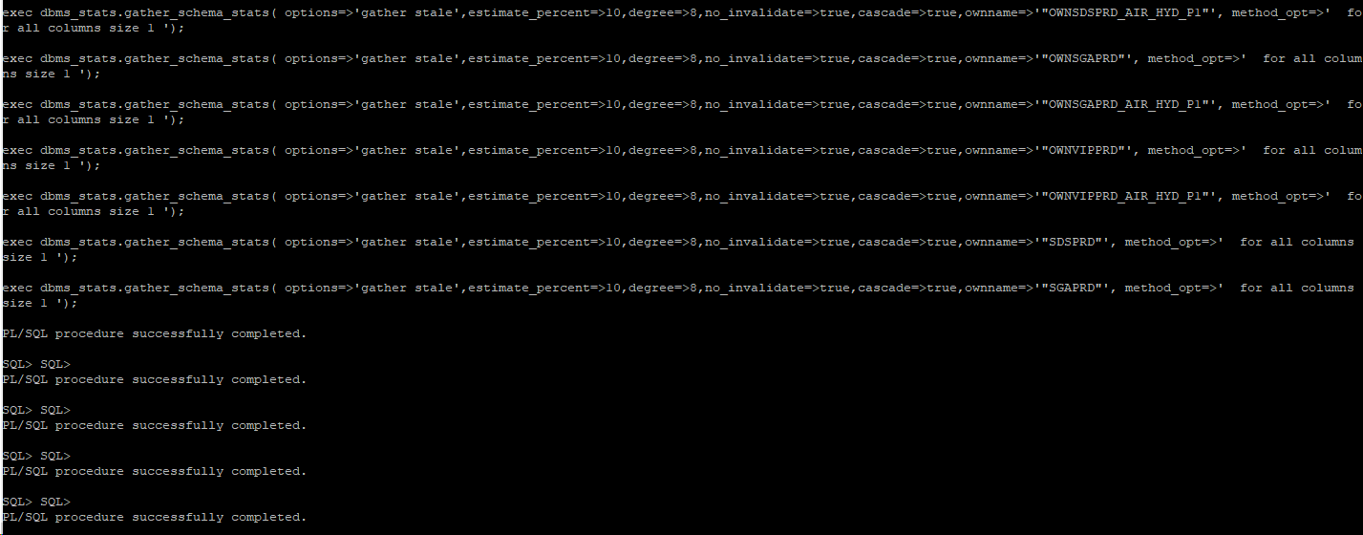

## IMBDB:

exec dbms_stats.gather_schema_stats( options=>'gather stale',estimate_percent=>10,degree=>8,no_invalidate=>true,cascade=>true,ownname=>'"IMBDB"', method_opt=>' for all columns size 1 ');



## LIBERTYDB:

exec dbms_stats.gather_schema_stats( options=>'gather stale',estimate_percent=>10,degree=>8,no_invalidate=>true,cascade=>true,ownname=>'"LIBERTYDB"', method_opt=>' for all columns size 1 ');



**2.INDEX REBUILD**

As there will be daily DB activities will be happening like DATA inserting and deleting in AMSPRD and also in IMBDB, LIBERTYDB and BAWDB.

The use of the rebuilding the index will helps to clear fragmentation in table, compacts the pages to that storage space and also rerecords the index rows.

We need to do this index rebuild at least twice a week.

AMSPRD (10.102.117.11/12):

Connect to the database,

We need to check any fragmentations available or not,

Command to check the INDEX - It will show the indexes, which are taking more than 25%

-- select only those indexes with an estimated space saving percent greater than 25%

VAR savings_percent NUMBER;

EXEC :savings_percent := 25;

-- select only indexes with current size (as per cbo stats) greater then 1MB

VAR minimum_size_mb NUMBER;

EXEC :minimum_size_mb := 1;

SET SERVEROUT ON ECHO OFF FEED OFF VER OFF TAB OFF LINES 300;

COL report_date NEW_V report_date;

SELECT TO_CHAR(SYSDATE, 'YYYY-MM-DD"T"HH24:MI:SS') report_date FROM DUAL;

SPO /tmp/indexes_2b_shrunk_&&report_date..txt;

DECLARE

l_used_bytes NUMBER;

l_alloc_bytes NUMBER;

l_percent NUMBER;

BEGIN

DBMS_OUTPUT.PUT_LINE('PDB: '||SYS_CONTEXT('USERENV', 'CON_NAME'));

DBMS_OUTPUT.PUT_LINE('---');

DBMS_OUTPUT.PUT_LINE(

RPAD('INDEX_NAME', 35)||' '||

RPAD('TABLE_NAME', 35)||' '||

LPAD('SAVING %', 10)||' '||

LPAD('CURRENT SIZE', 20)||' '||

LPAD('ESTIMATED SIZE', 20));

DBMS_OUTPUT.PUT_LINE(

RPAD('-', 35, '-')||' '||

LPAD('-', 10, '-')||' '||

LPAD('-', 20, '-')||' '||

LPAD('-', 20, '-'));

FOR i IN (SELECT x.owner,x.table_name, x.index_name, SUM(s.leaf_blocks) * TO_NUMBER(p.value) index_size,

REPLACE(DBMS_METADATA.GET_DDL('INDEX',x.index_name,x.owner),CHR(10),CHR(32)) ddl

FROM dba_ind_statistics s, dba_indexes x, dba_users u, v$parameter p

WHERE u.oracle_maintained = 'N'

AND x.owner = u.username

AND x.tablespace_name NOT IN ('SYSTEM','SYSAUX')

AND x.index_type LIKE '%NORMAL%'

AND x.table_type = 'TABLE'

AND x.status = 'VALID'

AND x.temporary = 'N'

AND x.dropped = 'NO'

AND x.visibility = 'VISIBLE'

AND x.segment_created = 'YES'

AND x.orphaned_entries = 'NO'

AND p.name = 'db_block_size'

AND s.owner = x.owner

AND s.index_name = x.index_name

GROUP BY

x.owner, x.table_name,x.index_name, p.value

HAVING

SUM(s.leaf_blocks) * TO_NUMBER(p.value) > :minimum_size_mb * POWER(2,20)

ORDER BY

index_size DESC)

LOOP

DBMS_SPACE.CREATE_INDEX_COST(i.ddl,l_used_bytes,l_alloc_bytes);

IF i.index_size * (100 - :savings_percent) / 100 > l_alloc_bytes THEN

l_percent := 100 * (i.index_size - l_alloc_bytes) / i.index_size;

DBMS_OUTPUT.PUT_LINE(

RPAD(i.owner||'.'||i.index_name, 35)||' '||

RPAD(i.table_name, 35)||' '||

LPAD(TO_CHAR(ROUND(l_percent, 1), '990.0')||' % ', 10)||' '||

LPAD(TO_CHAR(ROUND(i.index_size / POWER(2,20), 1), '999,999,990.0')||' MB', 20)||' '||

LPAD(TO_CHAR(ROUND(l_alloc_bytes / POWER(2,20), 1), '999,999,990.0')||' MB', 20));

END IF;

END LOOP;

END;

/

SELECT index_name, index_type, uniqueness FROM all_indexes WHERE owner = UPPER('&owner') AND table_name = UPPER('&table_name');

Here we have to select the name of the owner and name of the table.

Then we have to alter the index,

alter index OWNFOMPRD_AIR_HYD_P1.IDX_FOM_LEG_SOURCES_ID rebuild online parallel 8;



# **3.0 AWR REPORT (Automatic Workload Repository)**

It collects the process info, maintains the performance statistics for the problem detection. So that we can do self-tuning activities. It takes the data in the form of snapshots for every 15 min.

We can use this information to compare the statistics captured during a period of bad performance, so that to diagnose the performance issues.

1. Connect to the database AMSPRD (10.102.117.11/12)

1. And go to the location by using the below command,

@$ORACLE_HOME/rdbms/admin/awrrpti.sql

It will ask for the format of the AWR Report. By default it will be the HTML and we can select HTML.

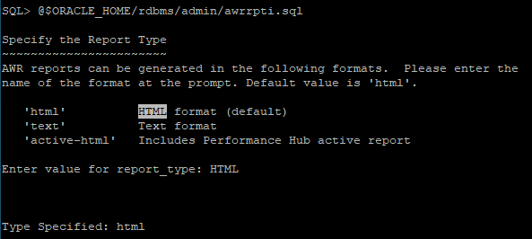

1. Select the DB Id and the Instance number

1. Take out the report as per the client for that Specify the number of days report detail dates we want to see

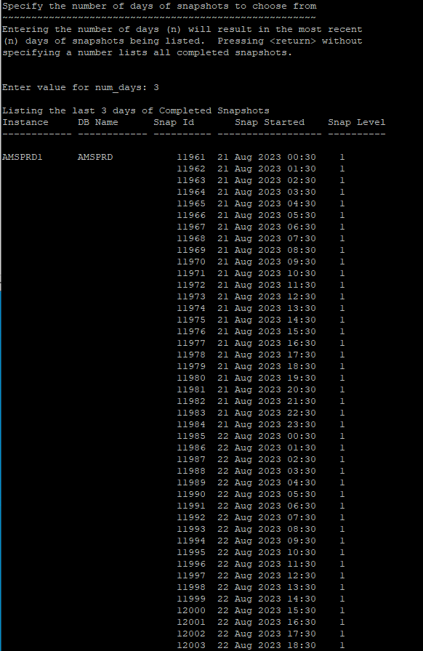

1. Select the Snap Id’s from what time we want and specify the name of the report.

Begin_snap: 12010

End_snap: 12020

Report generated,

1. Generated AWR Report will be in the home directory,

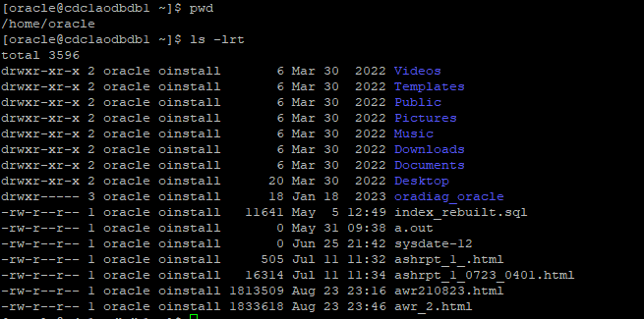

* Check the size of the report file,



1. Give the permission to the file so that we can to local system by using chmod command,

1. Move the AWR Report to other directory (/tmp) as because we can’t access the home directory using WinSCP



1. Now get this report to our local system using WinSCP,

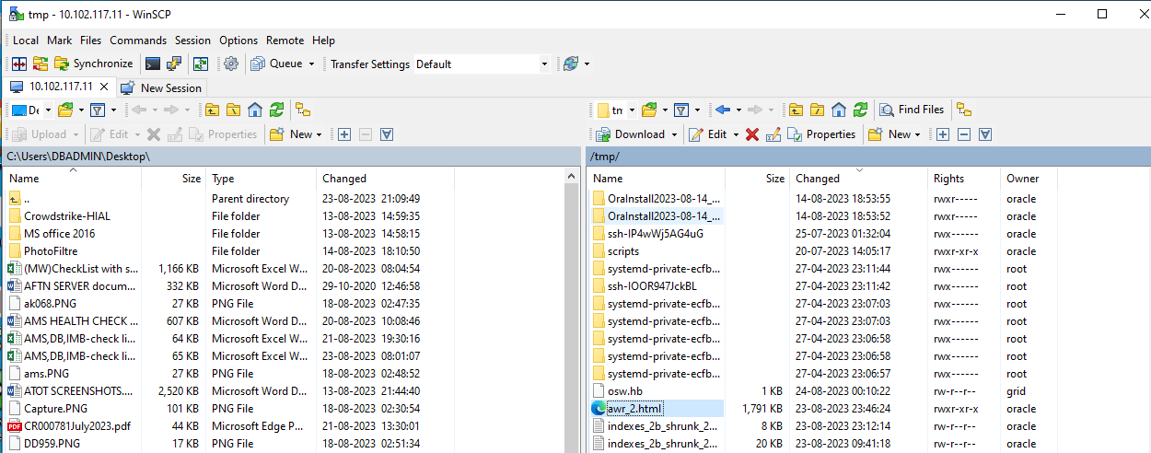

Select the report file, drag and drop into the local system,

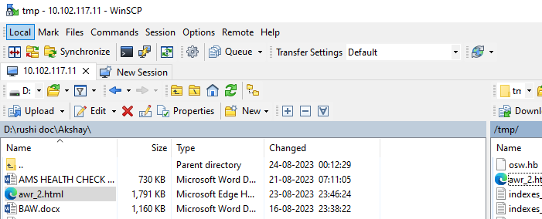

# **4.0 CLEARING THE FILE SYSTEM LOGS:**

Prdbawdb1 (10.102.123.11)

Check the mount files using – df -h

Choose the directory which consumed more space

cd /u01

As the directories owners are in the grid and root user we have change the owner to grid to check for the size of the directory.

* sudo su - grid

Go to those directory location from /u01. And get the size of the folders using du –sh * command. It take some time to calculate the size.

As we connected with the grid user, other users will get as permission denied.

As here oracle using having the more size go to the directory and check size of directories under oracle

Again go to the diag which having more size.

Again go to the tnslsnr which having more size.

Here listener_scan1 having more size so go that directory.

Go to the trace directory here as it taking more space. List out the trace directory here we can see the trace files.

* cd trace
* ls

We have to zip the old trace files so that the /u01 directory size will get reduce.

gzip listener_scan1_40.log

(NOTE: Here we should not zip the current logs.

.gz indicates that file get zipped.)

----------------------------------------------------------------------------------------------------------------------------------------------------------------------------------------------------------------------------------------------------------------------------------------------------------------------------------------------------------------------------------------------------------------------------------------------------------------------------------------------------